Epordo Time System Software Quick Manual

- For 5.0 or above version software only;
(this version for EK series device and ET series mixed type)
Note: 5.0 version or above support EK series device
Run should based on .net framework.4.0
There is something require to check if you use EK series devices
  - (mswinsck.ocx, this is required, but some OS don't have lisence, please add its lisence at regedit(run regedit in cmd window), create record : HKEY_CLASSES_ROOT\Licenses\2c49f800-c2dd-11cf-9ad6-0080c7e7b78d = mlrljgrlhltlngjlthrligklpkrhllglqlrk
  - ECardAPI.dll, mswinsck.ocx, Newtonsoft.Json.dll, copy it to windows/system32 or windows/SysWOW64 folder, and run regsvr32 to register these files. Cmd window should run as admin, otherwise it may fail.

)
How to run as admin for the cmd window
Take win 8 64 bit for example
Use the program Start find the cmd , select it , it will as below, then select the rum as admin
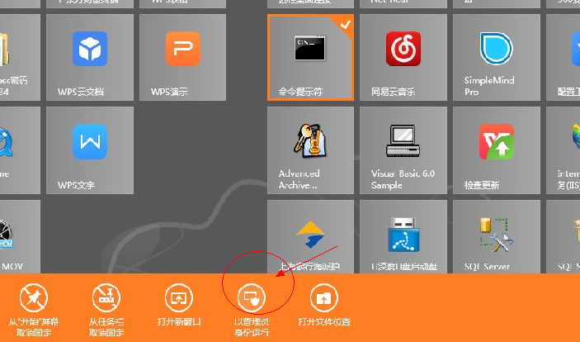

Copy the above mentioned file to the windows/sysWOW64(64 bit os should use this folder, 32 bit OS use system32

In the CMD window, if the file path is not sysWOW64, please use cd command to change the path(cd.. means back to the parent path, cd +folder name means enter the folder)

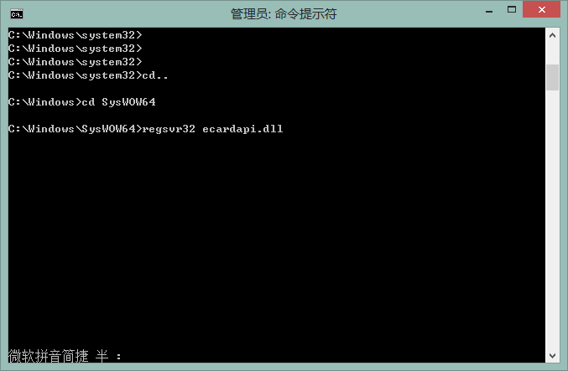
Also you can use this cmd window to open regedit
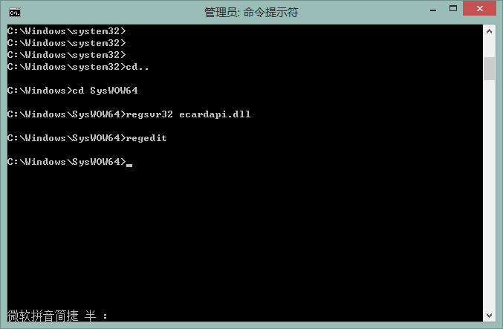
Then you will get such window, and find the path as below. Generally if the windows is installed properly, it will has such a key, no need create, if it don't have , please such a key.

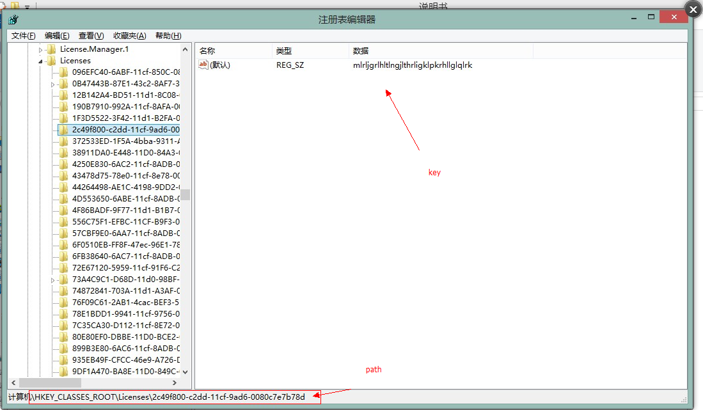

Also please note that, the .net framework is 4.0, if you have many .net framework version ,please activate it , it is in program of control panel of OS, select trun on /off windows function
It will give windows as below

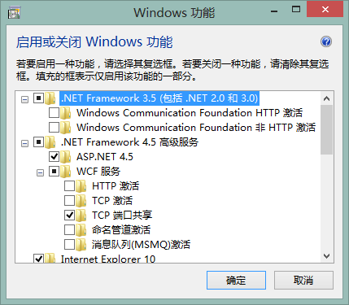

If you want to update 3.0 or above software version, please do this for database/
MS SQL database, please add data field Photo/Image type, in GlogData table,
MS Access database add data field Photo/OLE in Glogdata table in epordo.mdb

General:

Installation

If use XP or the Operating system don't have ..net framework installed.
You should install .net framework 2.0 .net framework 4.0 which you can download from Microsoft.com website, please install the version suitable for your operating system
If you use sql server and you don't have it , you can download from Microsoft.com also, the sql express 2012 studio is suggested.

Copy All the file to PC Disk, it is better not to use the same Disk as Operating System.
When you all the files, it is better to run as admin especially when you make installation
- Database Setting
The database default type is access database, database file name is epordo.mdb. if you can backup database you can backup this file, for more than 50 employee, please try to use Microsoft SQL Server, where I can get the SQL server? Buy from Microsoft or use their free version according the Operating System version, please download from Microsoft.com website, search the express version, it is free. If do not know how to install Microsoft sql server, search in google.com.
Run
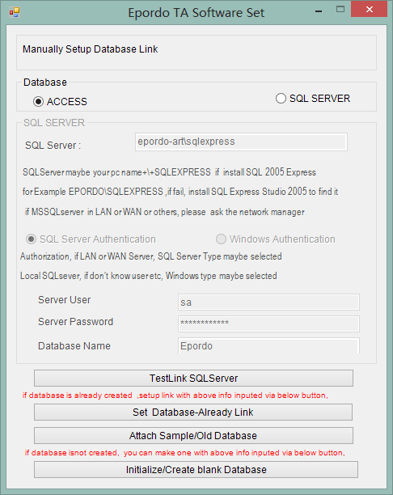
Click database type to select different type database, when you installed the sql server in the same PC as software, you don't know the user or password (which you need set in installation), you can use windows authentication, the SQL server name you should write correctly, then to click TestLink SQL server to test whether the server connection is ok or not, if failure, and the server name is writed correctly , check the server is stop or running.
After above is done, click initialized/create blank database(if you don't run as admin , it will fail)
Click database-Already Link button to save the database link
If you don't have SQL server, please go to the

- Registry Software

Run as admin, make sure the internet is available
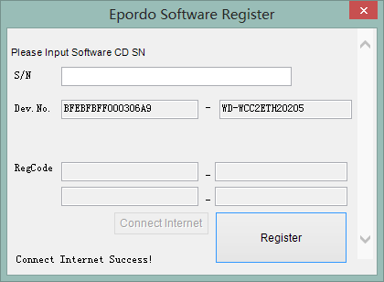
Find the SN on the CD label, input it at the blank textbox,

Tips: you can find the S/N on the CD. hint please don’t make mistake on I and one(1) for S/N
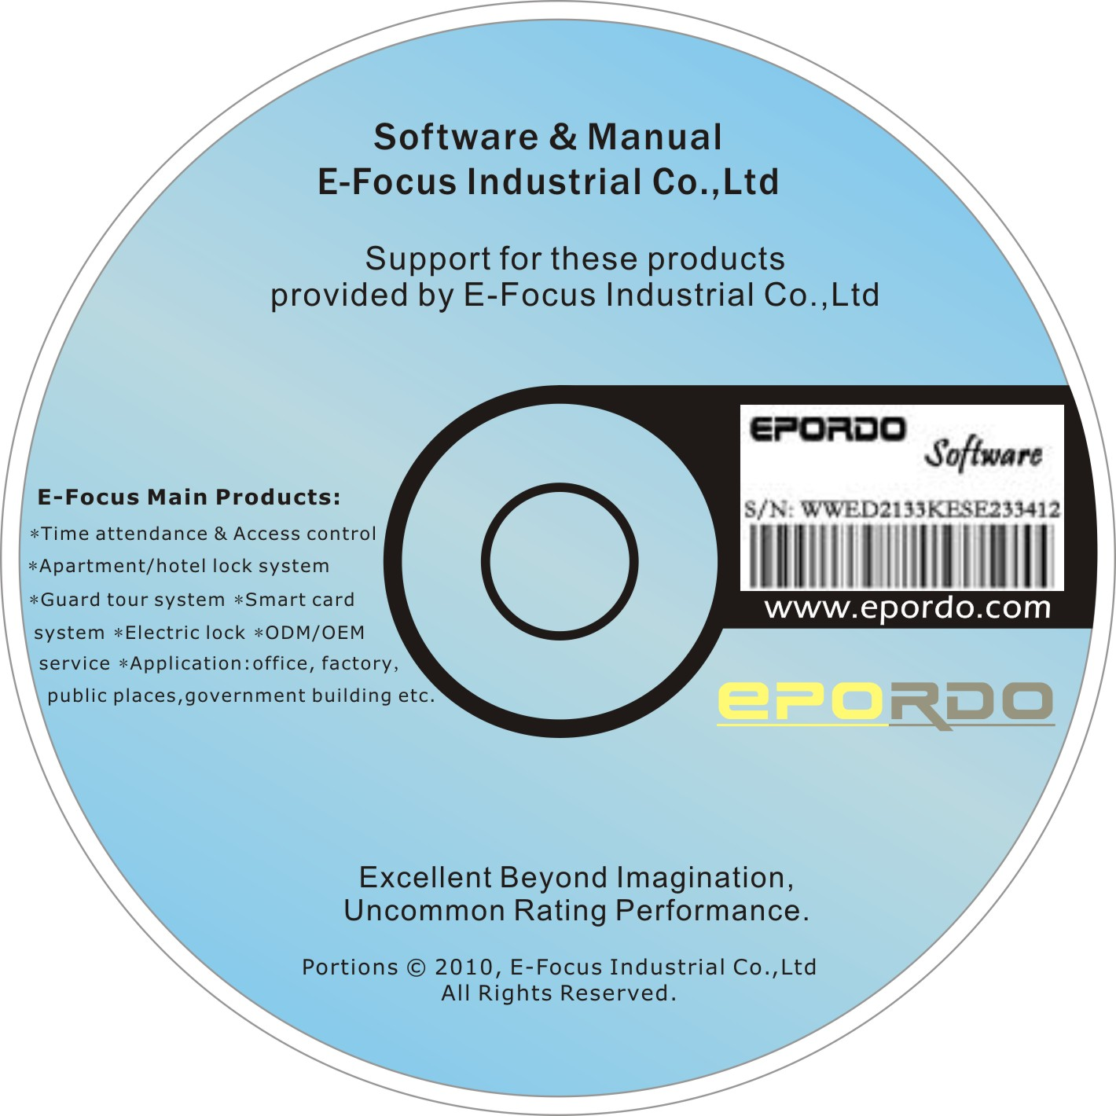

click register, if always failure.
Run as admin
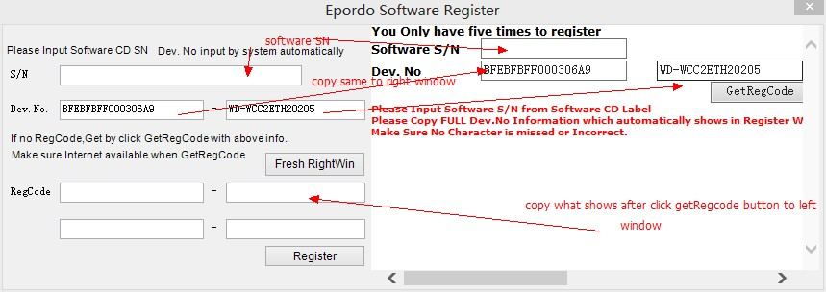

- Register device into software
Run as admin default User and password is ss and ss
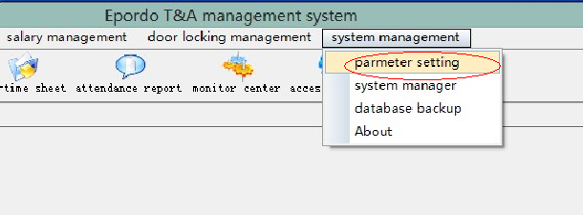
Then
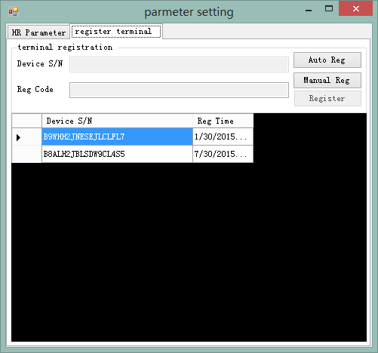
There it two way like register software. Auto Register please click the AutoReg button, if manual register , please click the Manual Reg button
Where to find the Device SN? Find the package box label of the label on the back of the device.

Also here you can set some basic information for the company, like company name, employee NoLength
And also some employee data field , you select valid, means you will use this data field, and also you can define the data field name here
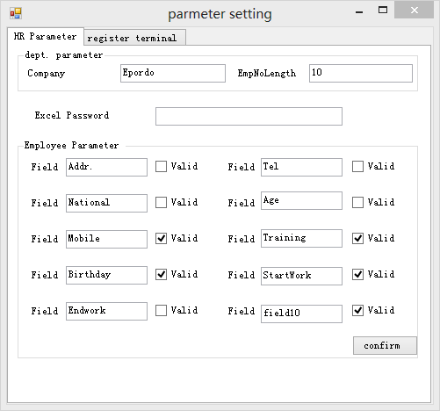

- Install a Automatically Receiving data Server (Option, not Must)
When you start the PC , it will run the server, it will help you to receive records from the device automatically and save it into database, also you can see the records at real time

- please check there is no software/function running to make the receiving data fail, for example, some firewall.
- And also you should set the three setting in Device:
Server: your PC IP address or Public IP(internet IP)
Port: the Port you used in the DataReceivingReal.exe, default is 7005 ( if you use the Public IP , you should do the port forwarding setting in router to your PC IP, and port should be same)
Server Req: set it as Yes
Device should connect via TCPIP, or Wifi, or GPRS

- Run as admin to install

4. you also can run after you installation to see the function
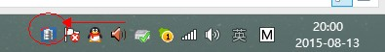
click the icon above

it will shows
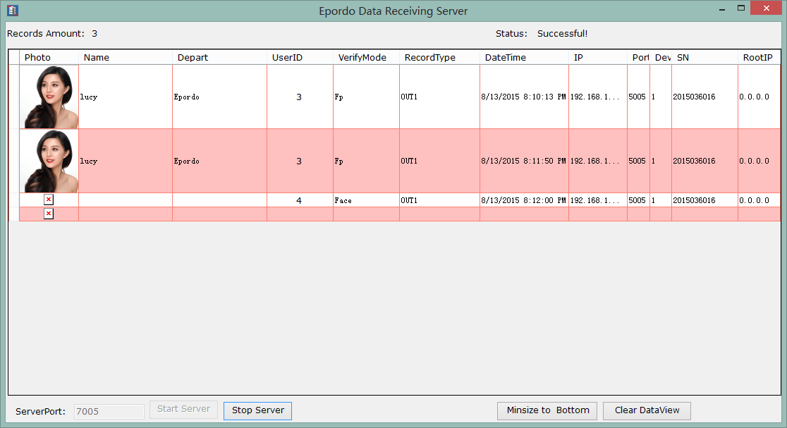

How to use the System

For new interface 4.5.1 version explain:

In order to give a friendly interface, we make the software function to four main parts:
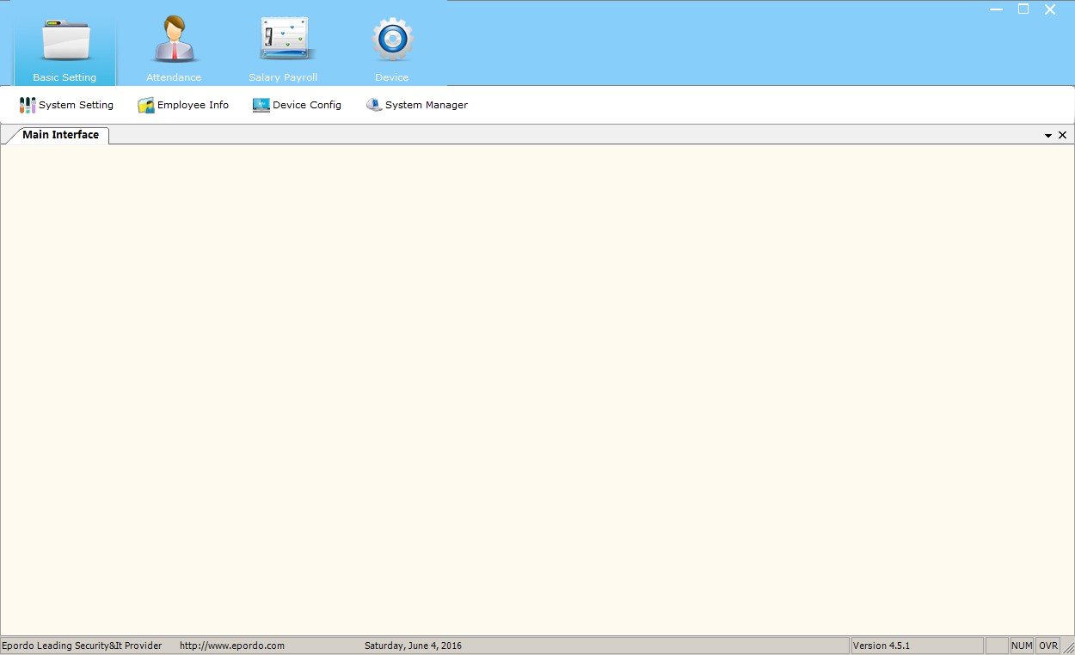

This design is based on software using flow, basic setting --- attendance--- payroll—device
These four part include all the functions:

- Employee or User Input.
Define Department enter employee management window select the company name click right mouse key to add/delete/modify department.
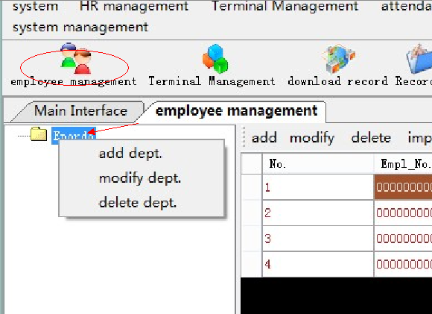

Add user / employee, there is two ways

First please note that employee number(empl_no) is the same as the user ID in device, software will combine them together.

The first way is to add employee from the window above, then go to register user’s finger etc data into device and download it to software via below window(before you download, please add the device into software, the menu is terminal management-→terminal management, also there is many function there, like delete admin user and delete all data and all user etc, and adjust the device datetime)
Menu：
Terminal management-→ download User Info.
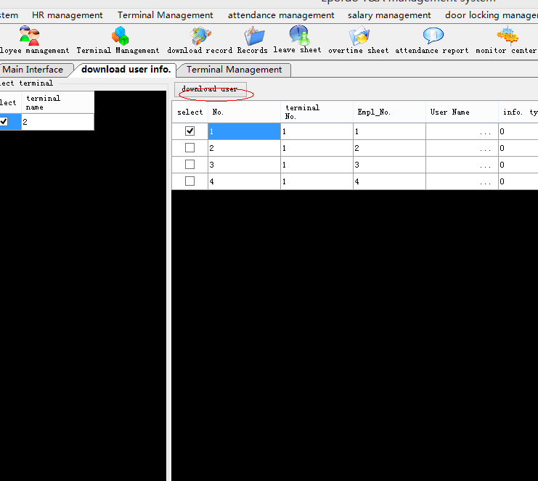

How to upload user data and delete user data to or from device for some user

Terminal Management-→ upload user info.
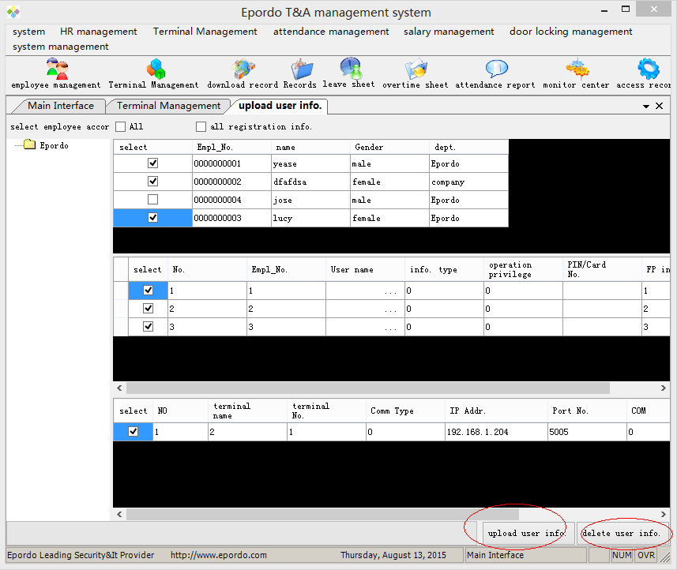

The Second way to add user : first register user into device ,then download into software
Terminal management-→ download User Info.
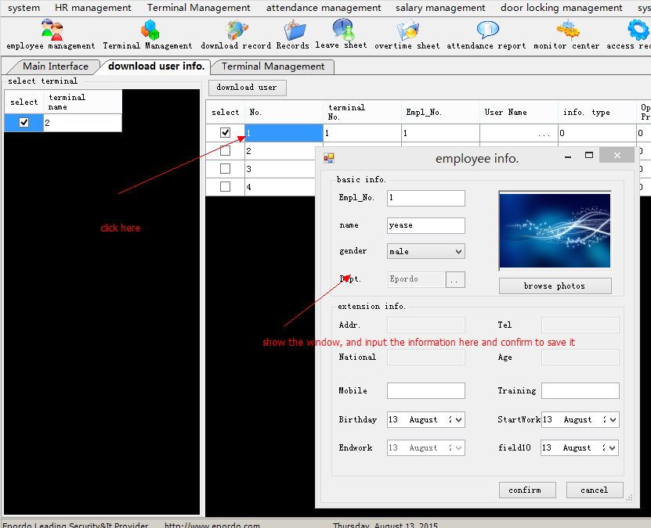
Other steps is same as above first way

- Attendance Management

Work Flow
Add Shift----> Add Section---->Add Shift scheme-----> Add Shift scheme to Employee---->Make Report -----> Print or Save Report-----> Salary Function

First to tell some Special Case dealing solution:
- employee forget to punch finger or need input record for employee
Manual add records will be showed as manual add, and who add, if download from device will show terminal type
Menu: Attendance Management-→ Records management
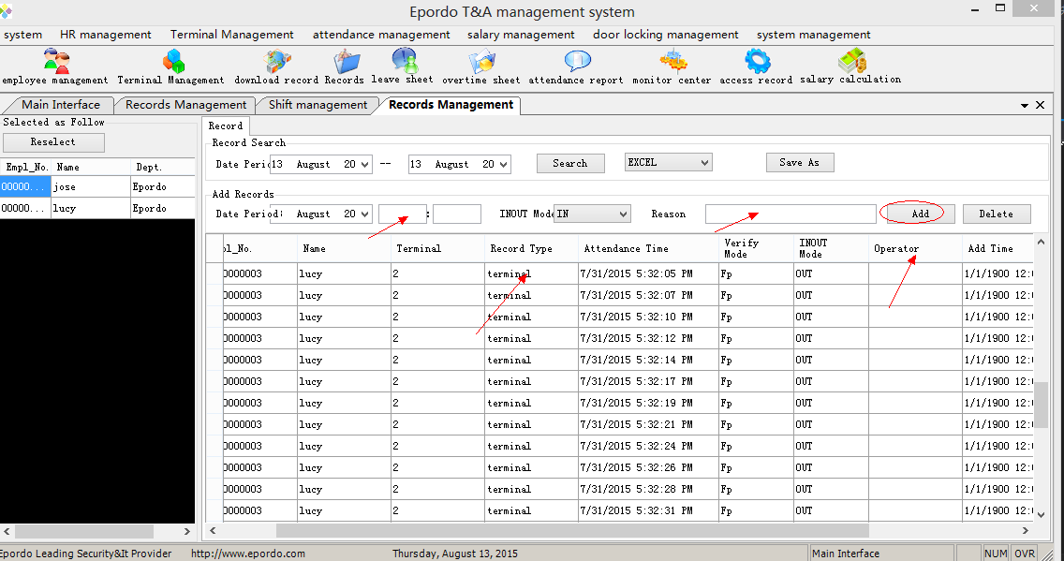

- Some employee ask leave from work, how to do
The system is smart, if there is a leave period you input, and also the time period cover the work start time or work end time , it will not make error, like late, or earlier leave etc. also you don't need to change the work shift setting.
Also you can make leave sum report
Attendance management--→ Leave management
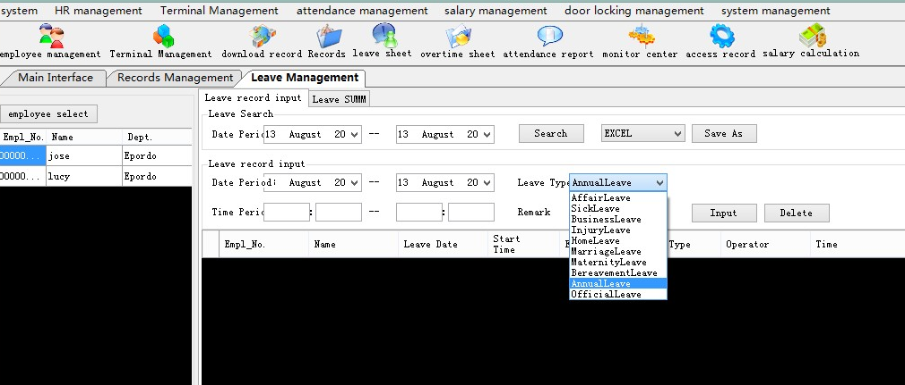

- Some special work time , which don't need to or they cannot punch finger/card etc. for example, special work time without shift setting, work outside, special work which is not easy to calculated by device etc.
Attendance management-→WorkTime Manually Add

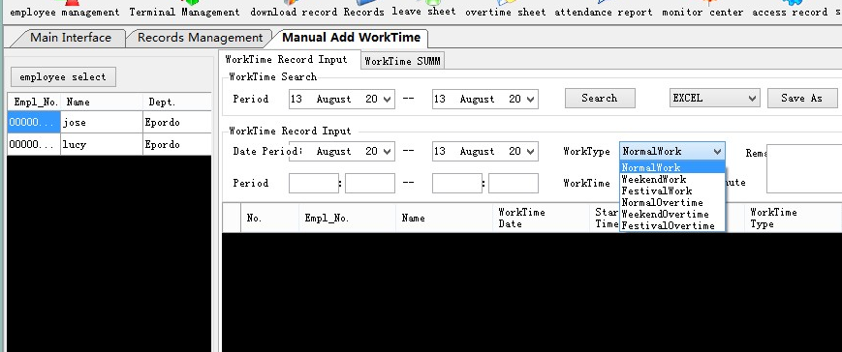

Second we learn how to create attendance rule for employee
There is two menu will be used to create attendance rule:
Attendance management--→Attendance Rule Setting: for basic work rule define
Attendance management-→shift scheme management: for work plan design, and give employee work plan.

The first one:
1. basic setting: leave type setting, this will be for you to define which need pay and which you don't need to pay for the employee time leave.
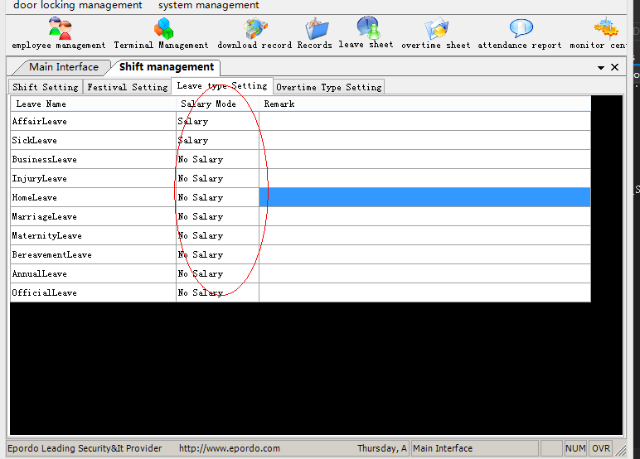
- work time period setting.

There are three type work, normal type work(normal shift), weekend work(weekend shift), festival work (festival shift) , also please note that, one day only can have one shift, overstep day type work also have one shift., means one shift can include only max 24 hours.
In order to recognize the different shift, the shift can be settled as different color, how operation please check software window, it has words to tell how to do
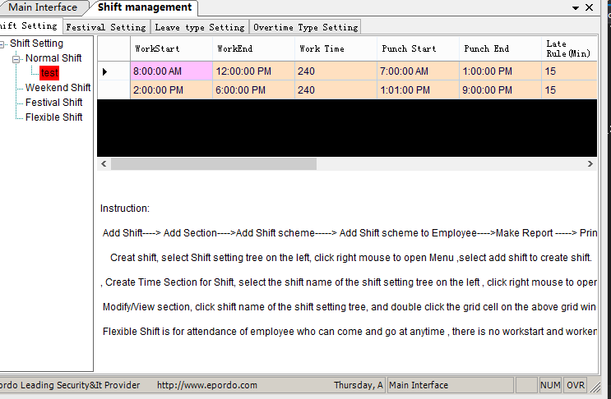
One shift can include many time sections, one time section setting is like below, details also please check the explain on the window
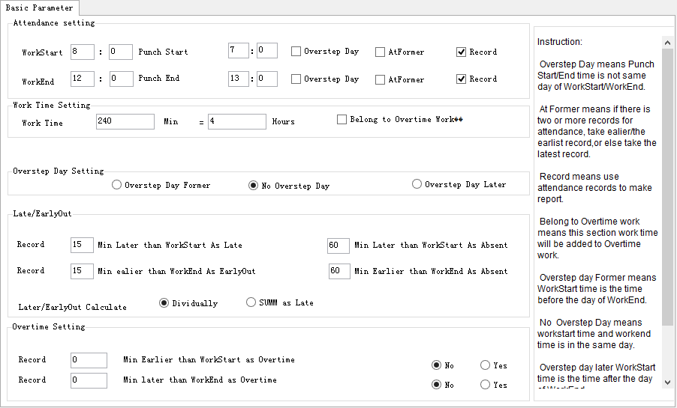

Here for some special case:

Lunch time and rest time how to set it? In the attendance shift, there is no lunch time and rest time define, any time period between two work time section, you can take it as rest time or lunch time, or any other special time for a workday.

How to make overtime work? please check the time section setting , overtime setting , and belong to overtime work option

Other special case, please find solution in time section setting, and shift type.

The Second One:
- shift scheme
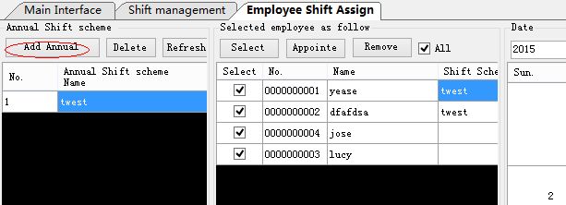
One shift scheme include date and shifts which you defined above.
How operate also is write in the window, please read it
you can use mouse select many days to give them shift or change their shif
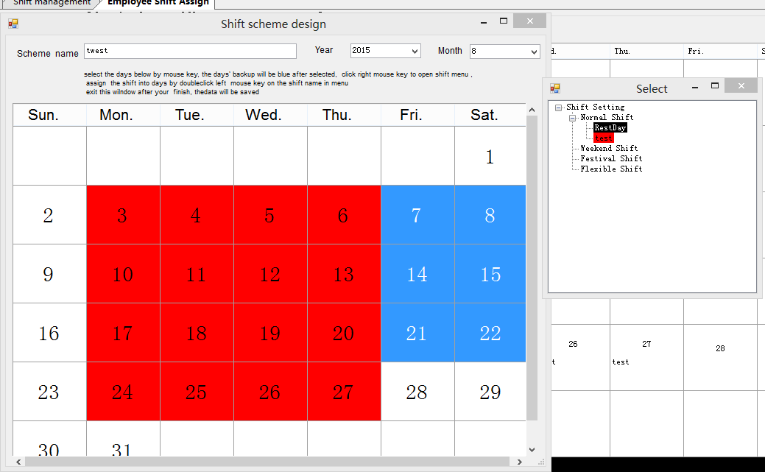

If you want to set it back to rest day or holiday, just need to set it as RestDay shift

Via the way, you can set any date as rest day or holiday, it is very flexible. And also it is easy to make changes, it will not affect other days’ worktime, because each day can has one type shift.

- assign shift scheme to employee
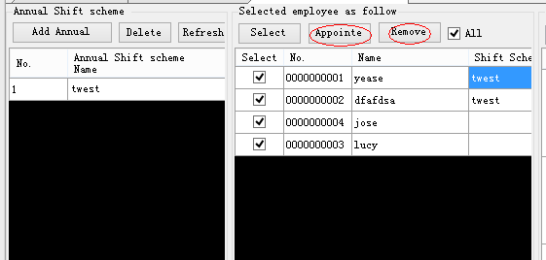
After the employee is assign the shift scheme, you can double click the employee, at the right window will show the shift in the recent month , also you can select different month to see other month’s details

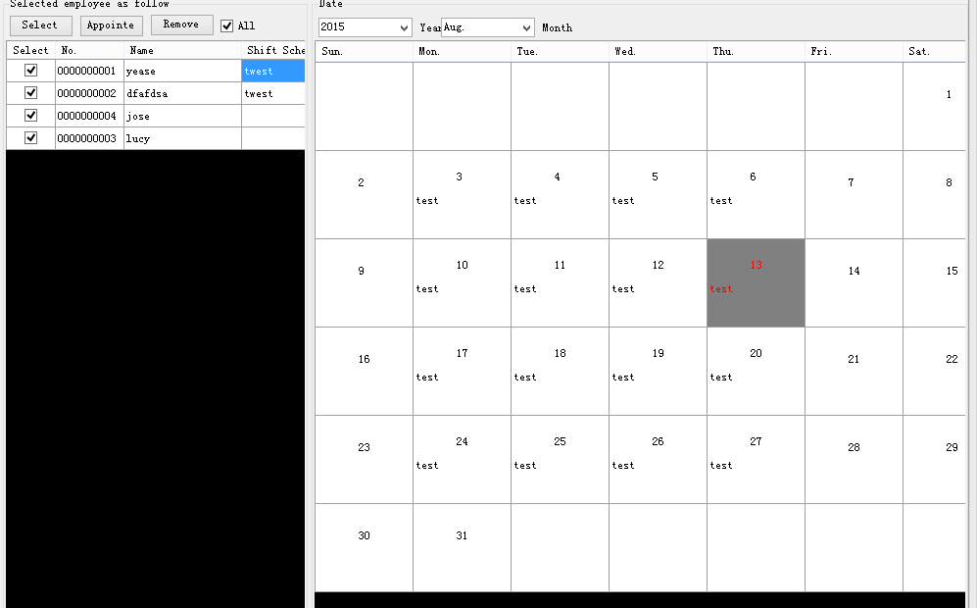

Attendance Report

Download the records from device then you can make report , it easy. Will show like below
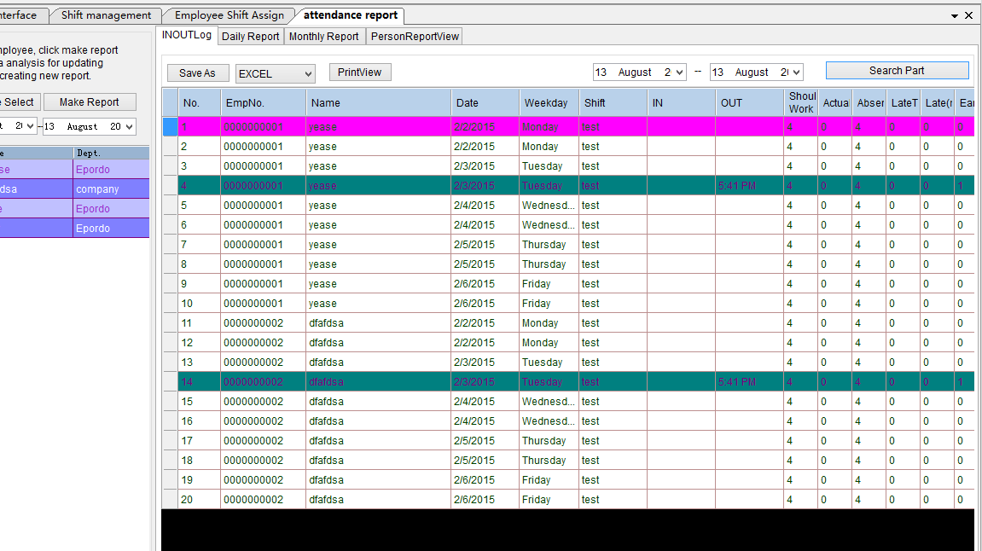

Different color is to tell different meaning, it for you to easy to find the different records.
Now I am tell how to define your own type formate output report.
- print , pdf, or tif output
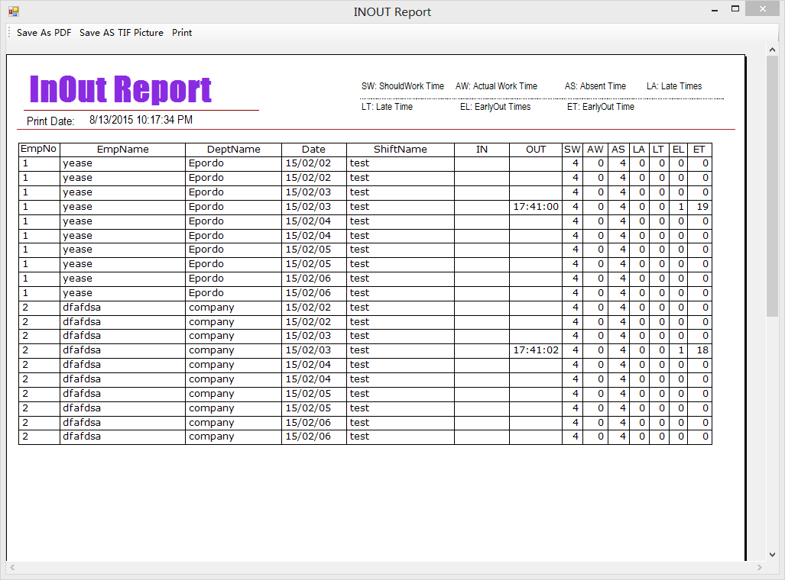
Run the 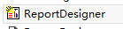, when you want to modify files, please backup them first to avoid any problem. After you make changes , please save it.
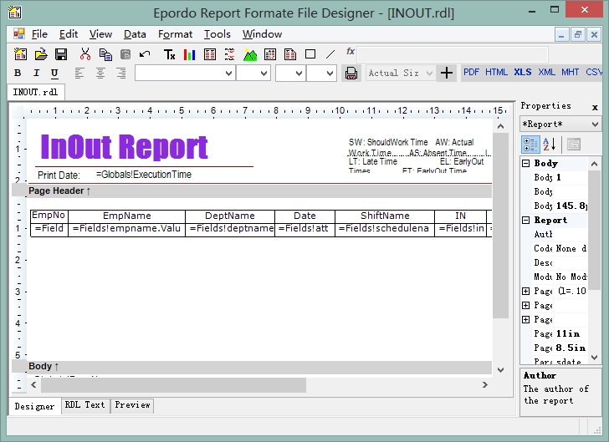
You can open the files as below
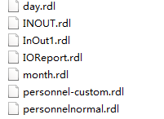
After you open above window, you can open the file in software folder
- day.rdl is for daily report
- INOUT.rdl is for In and Out report
- month.rdl is for month report
- personnel.rdl is for personnel report
Now I open Daily report as example

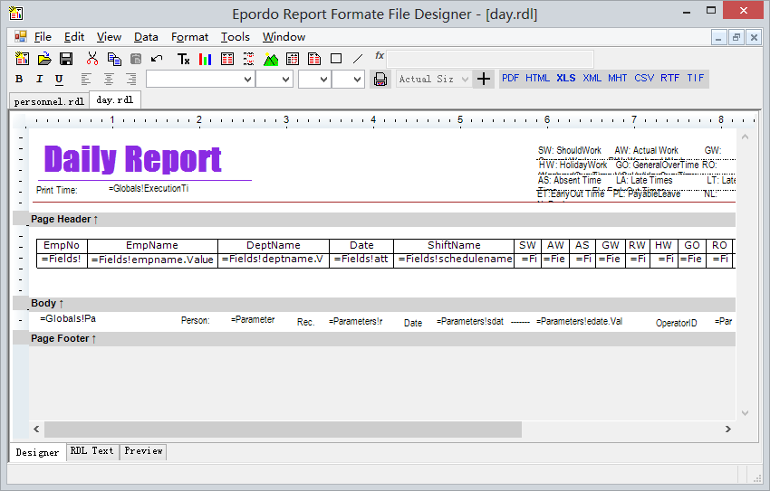
some Key information for your reference:
the parameters with Globals!, this is from system data, you can put it at report header or footer
the parameters with Parameters!, this is from software data, you can put it at report header or footer
the parameters with Fields!, this is from software datagridview, you can put it at report body.

You can input picture, words and table into report by yourself.
By the way, not all the data available for your selection can work, you can do a testing by making report in software after you make a change.

The way here is only for some simple changes, if you need more changes, you should contact your supplier.

- excel output
the file is store at template folder, you make your own type template to output data to create a excel report by yourself.

attendtm.xls is the excel template file for personnel report
attendMonth.xls is the excel template for monthly attendance report
attendDaily.xls is the excel template for daily attendance report
attendInOut.xls is the excel template for IN OUT attendance report
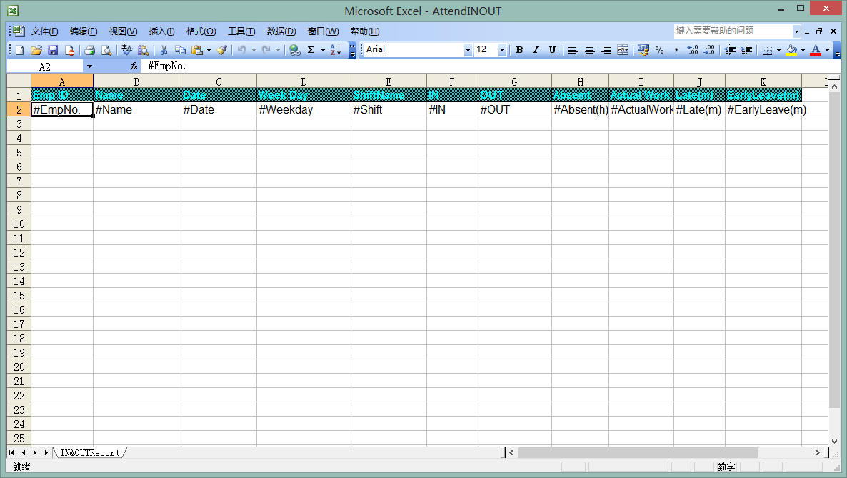
I open one excel template for your reference
The personnel report
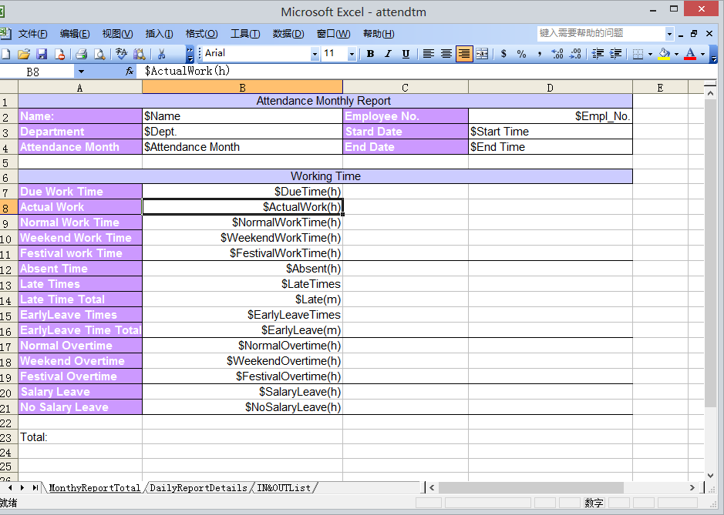
The words with $, @, # is data which will be input by software automatically
How to know the data
For example: $SalaryLeave(h)
Without $, other words should be same as the column name showing in software
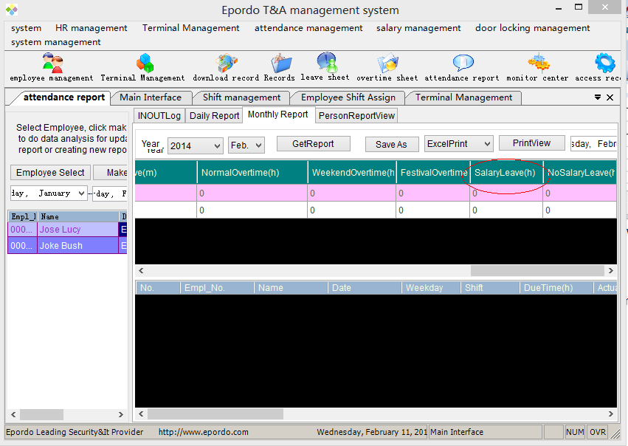

3. personnel report function
First you should select a date period
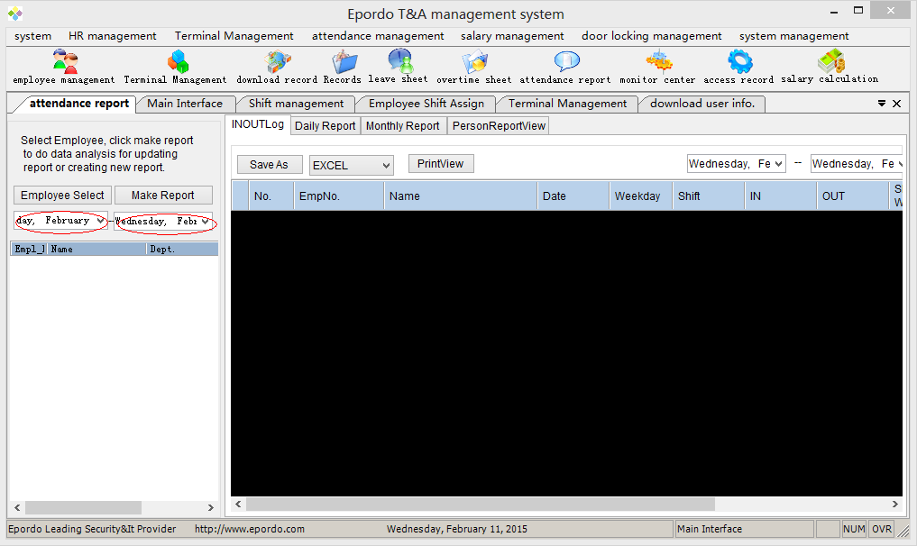
Then select employee
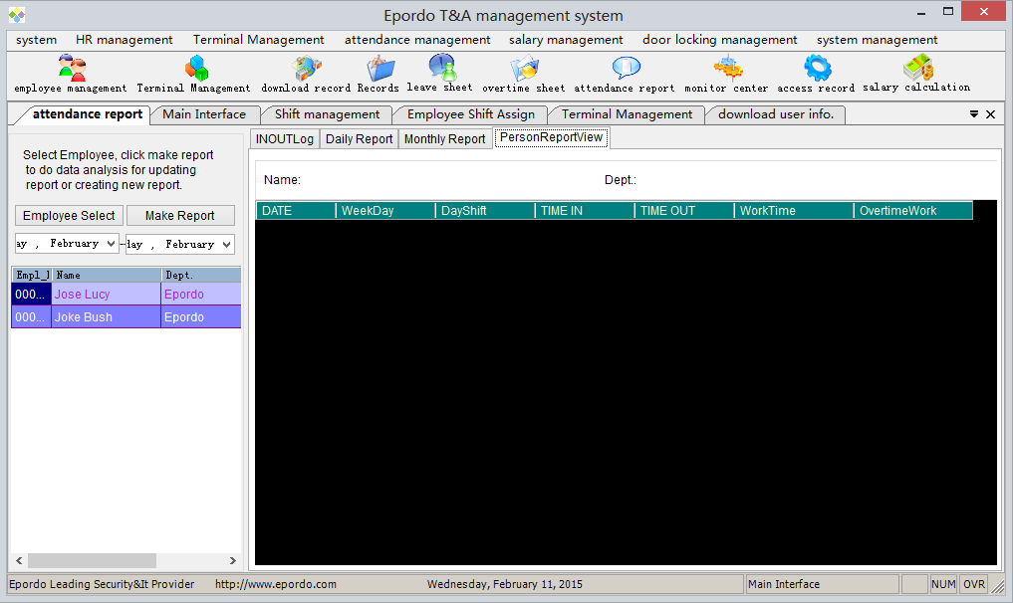
Make sure you had made report for the period you selected, if not, please click the make report to make report.
Then double click the employee you will get the data showing like this
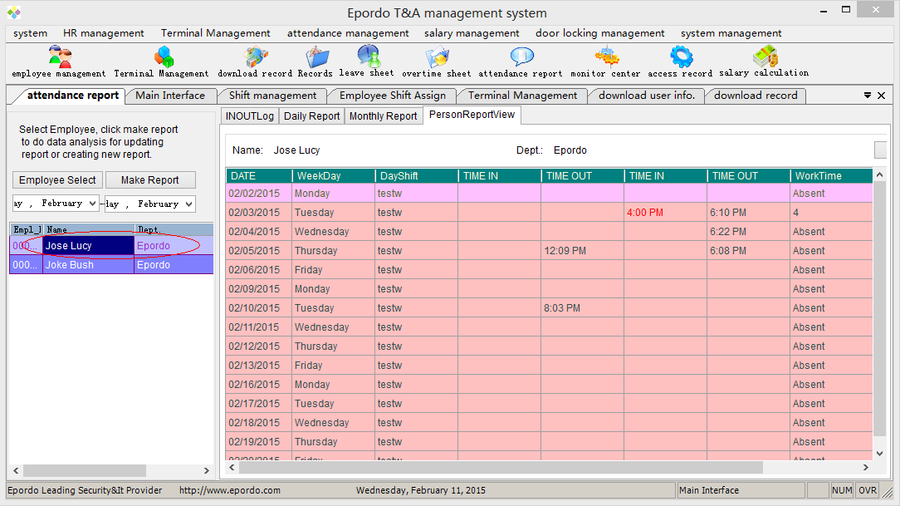
Then you can click the printview to get pdf or other type report.

Salary Function.

Standard flow to make a salary report:
ONE-TWO-TWO

One basic:

first, you should make sure the time attendance report work well,

Two define:

1. salary items define
define fixed salary item ,flexible salary item, ans salary item as you need,
fixed item, mean each period or month you should pay at this item's value, it is same each month
flexible item, also you should pay per each month or period, but it may be at a different value salary item also is for each period or month, but this is not input manually, it is calculated according the formula you setup, if you define such a item, please move to the salary formula define window to define its formula.

2. month or period info define
you can define different month or period which including different days, also its parameter like workingdays etc can also be used in formula

Two Input Value:

Fixed Salary Item Value Input
input fixed salary item for each employee, at least all the employee you want to calculate salary
Flexible salary value Input
do the same for flexible item input, moreover, remember input all period you defined, and don't forget to save, otherwise you will fail to make salary report

How to Define Salary Items

1. space is not allowed:

all the items defined should not have space like ''monthy pay'', it must be ''monthy_pay''
2. '',+,- ,/. (,),*,etc operation can not be add to item name

Income tax rate setting:

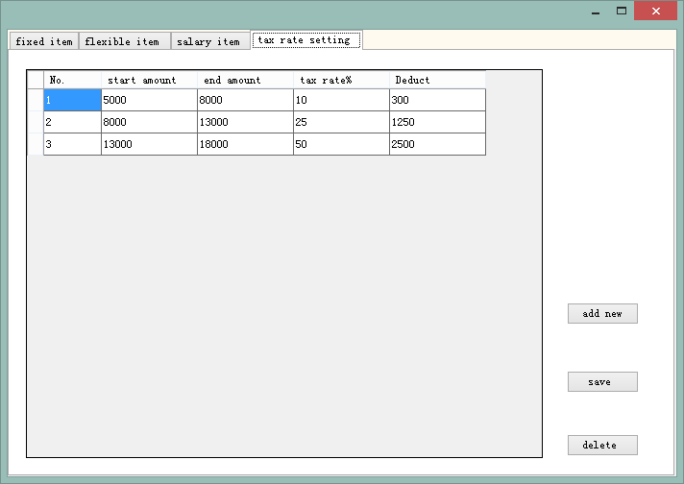
Please add you level of the income tax rate you should input start amount and end amount , and rate, it calculate the value between start amount and end amount, for example a value 15000, according above setting, the tax value will be calculate as following, 15000 is more than 5000 and 8000, 15000 is more than 8000 and 13000, and 15000 is more than 13000, the tax will be (8000-5000)*10%+(13000-8000)*25%+(15000-13000)*50%=300+1250+1000=2550;

Salary period setting
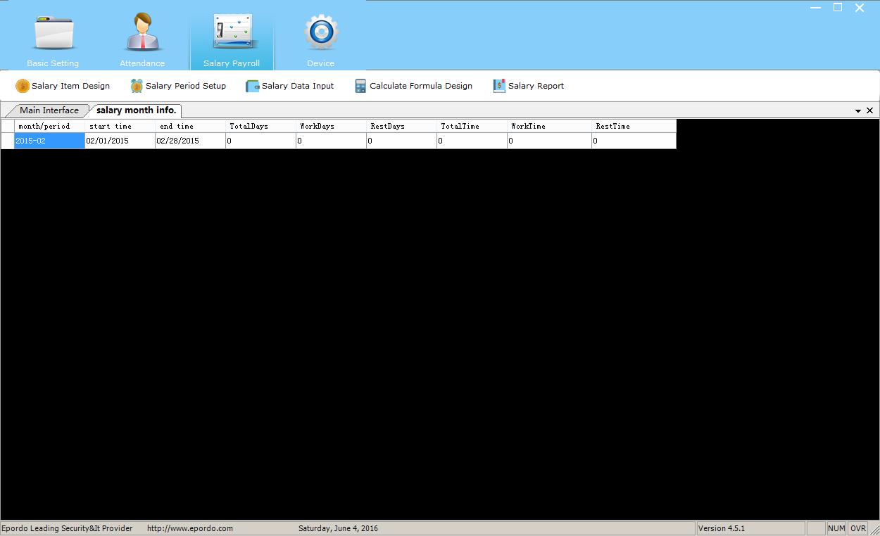
Click right mouse key to open the operation menu to add new ,delete and save

Start time and end time
This will be used for calculate the attendance report data for this salary period, it like attendance report function,

For other data like totaldays, workdays, rest days, these data you can use for your special requirement, for example, you can input a totaltime to set a rule like this, if the worktime(which you calculated according the start time and end time in attendance report) of employee is less than this value, you will deduct money from the salary,moreover, you can use all these data field for your special purpose

Salary period setting is a must basic setting for payroll

Salary data Input:

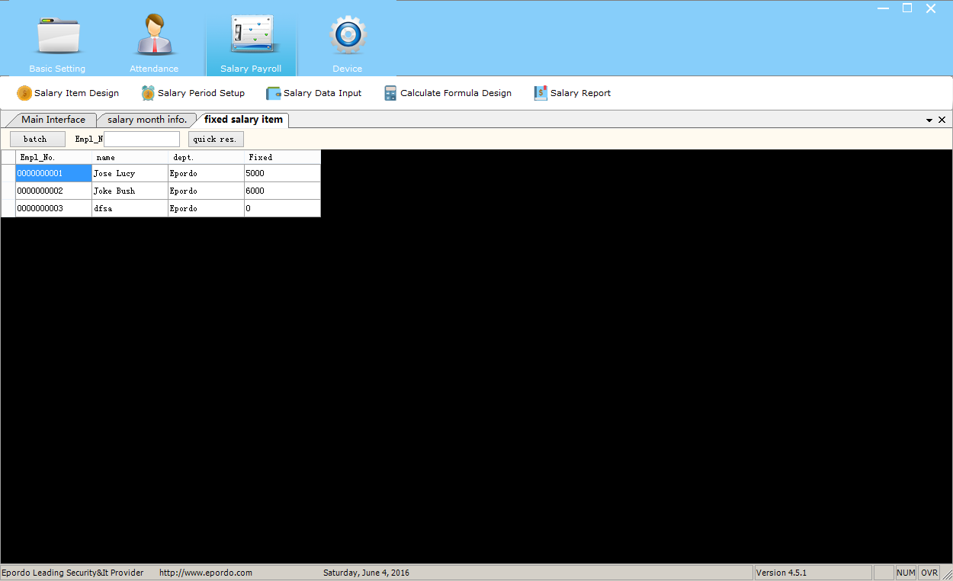

There is two type salary data input , one is fixed type, the other is flexible salary type
After you select the employee, you can input or modify data in the table as you want, and click the right mouse key to save it, please note all the data should input , zero also should input and save it
Fixed salary input, only input one time is ok, because, it will be same for each salary period, flexible salary input should input for each period you design.

Sarlay formula design
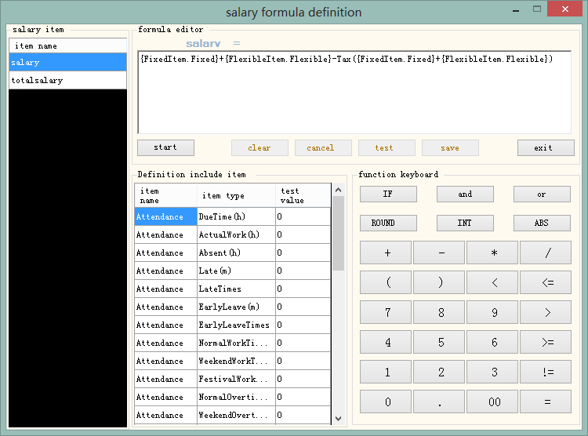

Each salary item you add in salary item design window, you can design a formula for it here, for a formula you can use 4 types data and functions

4 Types data
Attendance: this data will calculated in total from the salary period you settled (start time and end time)
Leave: this data will calculated in total from the salary period you settled (start time and end time)
Monthinfo: this data is you input manually when you make salary period
Salary Item: fixed item and flexible item data , also is you input at former step, regarding SarlaryItem, please Note that you can not use a salaryitem which is behind of it , because it don't have any value
Take above window for example, you can use salaryitem salary in salaryitem totalsalary, but you cannot use totalsalary in salary formula.

All the data has a test value here, you can input it for testing.

Functions: there is IF(), Round(), INT(),ABS() for you use, and Tax() (this you should add it manually)

How to design a formula:

Select the salary item, click start to design the formula, if it has old data or you want to clear it, you can click clear button to modify or add new.

If you want to use the the 4 types data, you click it in list, it will input automatically

Now take the example mentioned in salary period for example: click IF button
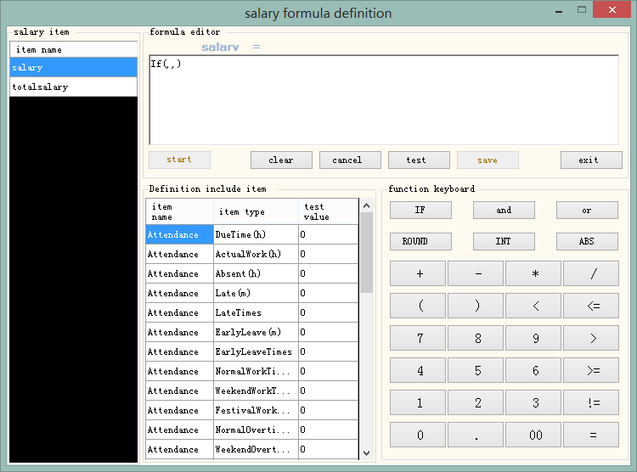
Design the rule result value: (we can use mouse to select the position of the formula to input the data items)
design the rule via select the data and operation , totaltime deduct actualwork time, you can use and or in it , if the rule you set is complex

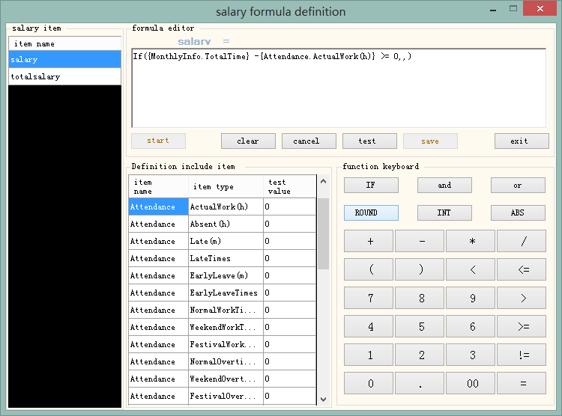

Now design the result value, {MonthlyInfo.TotalTime} -{Attendance.ActualWork(h)} >= 0 is true, the If value is ,{FlexibleItem.Flexible} * 2, {MonthlyInfo.TotalTime} -{Attendance.ActualWork(h)} >= 0 is false, the If value is 0
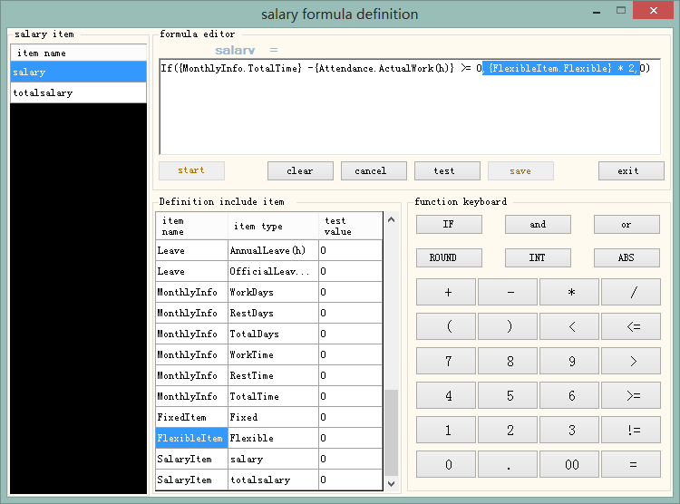

Now give value to the data I used in test value, total time 8, actual 6, flexible 1, to test the If value,
Click test button, it shows
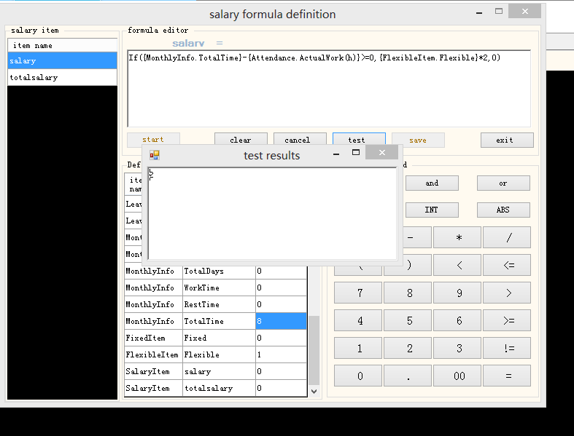
It shows 2 as result;
It is correct as we think.

Now we add fixed salary and flexible salary and deduct this If value as the salary item value

it will show like this
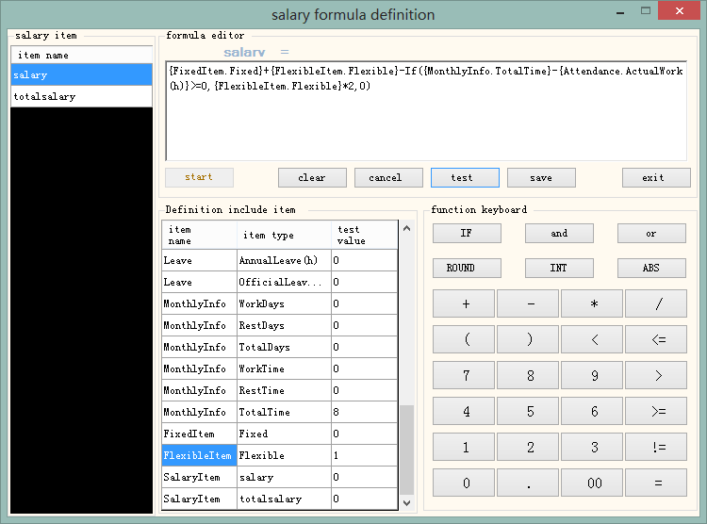

Input test value , click test button to check it correct or not,

Then click save button to save it, one simple formula is design

Now I give another example for the totalsalary item’s formula design
Here we use Tax() and salary item
(Tax() we can input it into formula manually)
The formula is :

{SalaryItem.salary}-Tax({SalaryItem.salary})-If({Leave.AffairLeave(h)}>0And{Attendance.NormalOvertime(h)}<0,{Leave.AffairLeave(h)}*100,({Leave.AffairLeave(h)}-{Attendance.NormalWorkTime(h)})*100)

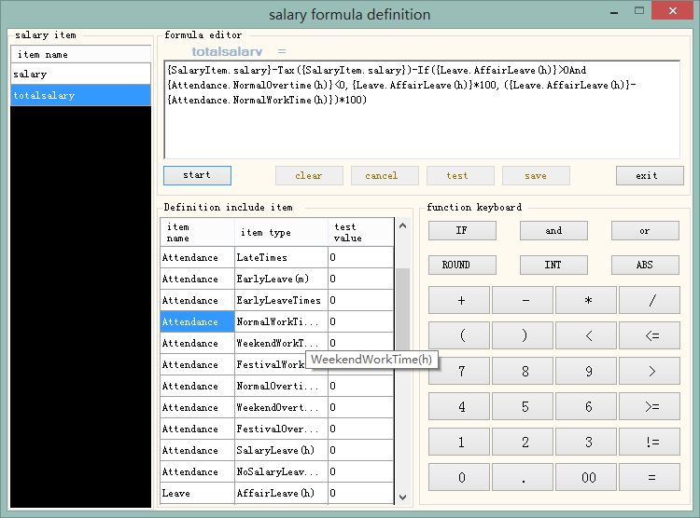

After you do all the setting, then you can go to make payroll report.

Note: Regarding EK series Remote download testing Server IP is 52.27.165.236, port is 8000 you can use in device add window, please input the server IP at the domain input txtbox, and select internet connection. Port input 8000, also please set the server IP and port in device manually/ then you can communicate the device via Internet

